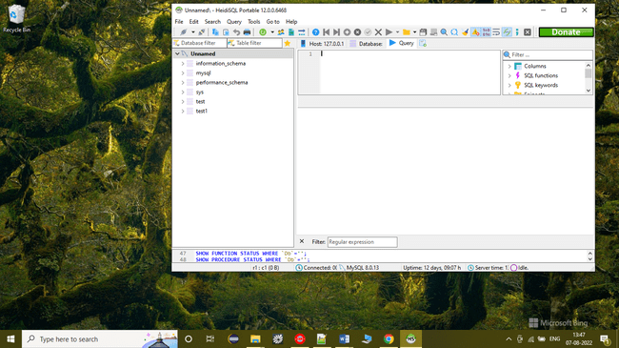

CREATE DATABASE restaurant_managment_system;

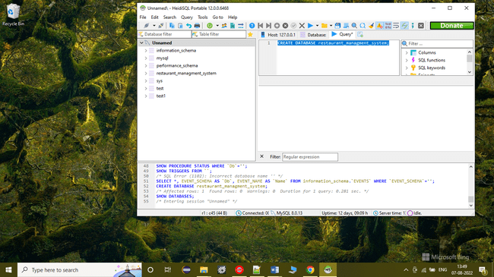

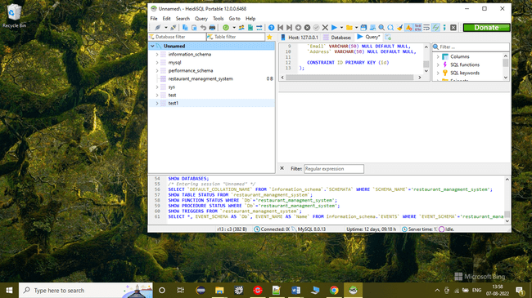

**CREATE** **TABLE** `Restaurant_Staff` (

`id` **INT** **Not** **NULL**,

`name` **VARCHAR**(50) **NULL** **DEFAULT** **NULL**,

`role` **VARCHAR**(50) **NULL** **DEFAULT** **NULL**,

`department` **VARCHAR**(50) **NULL** **DEFAULT** **NULL**,

`Mobile` **VARCHAR**(50) **NULL** **DEFAULT** **NULL**,

`Email` **VARCHAR**(50) **NULL** **DEFAULT** **NULL**,

`Address` **VARCHAR**(50) **NULL** **DEFAULT** **NULL**,

**CONSTRAINT** ID **PRIMARY** **KEY** (id)

);

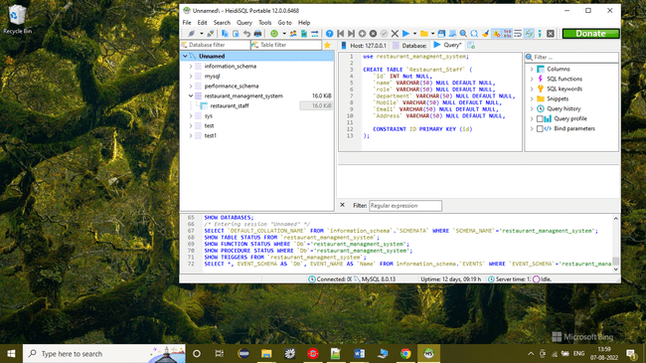

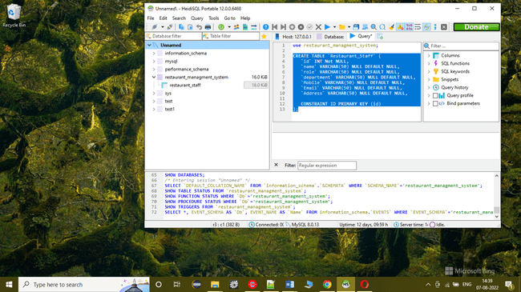

CREATE TABLE `Orders` (

`id` INT Not NULL,

`menu_id` int not null,

`table_no` INT Not NULL,

`customer_id` INT Not NULL,

`staff_id` INT Not NULL,

`Datetime` VARCHAR(50) NULL DEFAULT NULL,

`quantity` INT NULL DEFAULT NULL,

`subtotal` Float NULL DEFAULT NULL,

CONSTRAINT ID PRIMARY KEY (id)

);

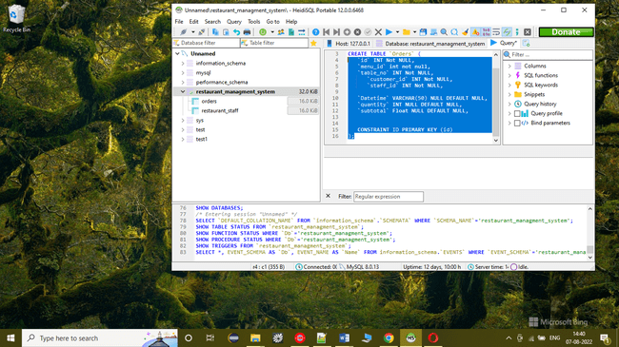

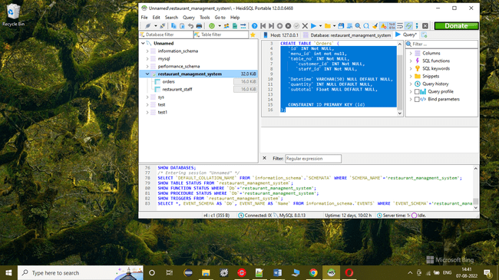

CREATE TABLE `Menu` (

`id` INT Not NULL,

`name` VARCHAR(50) NULL DEFAULT NULL,

`cost` Float NULL DEFAULT NULL,

CONSTRAINT ID PRIMARY KEY (id)

);

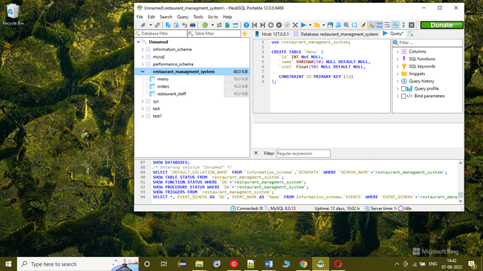

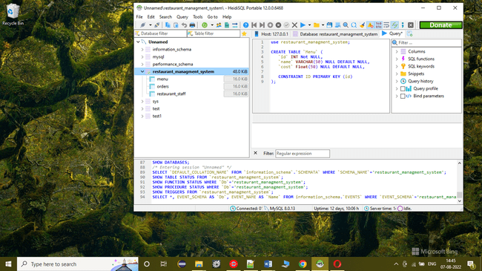

CREATE TABLE `Reservation` (

`id` INT Not NULL,

`customer_id` INT Not NULL,

`datetime` VARCHAR(50) NULL DEFAULT NULL,

`number_of_guest` INT NULL DEFAULT NULL,

CONSTRAINT ID PRIMARY KEY (id)

);

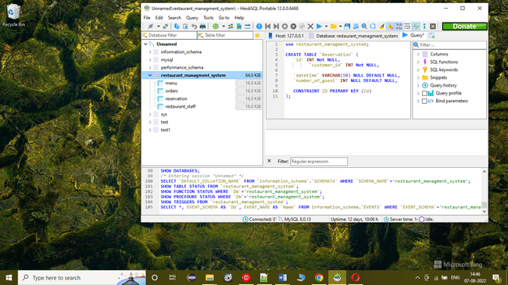

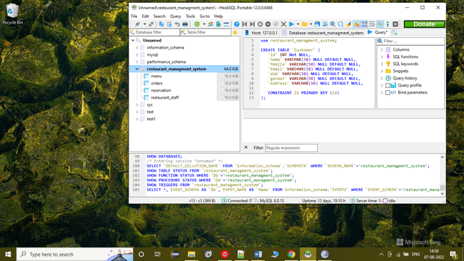

CREATE TABLE `Customer` (

`id` INT Not NULL,

`name` VARCHAR(50) NULL DEFAULT NULL,

`Mobile` VARCHAR(50) NULL DEFAULT NULL,

`Email` VARCHAR(50) NULL DEFAULT NULL,

`dob` VARCHAR(50) NULL DEFAULT NULL,

`gender` VARCHAR(50) NULL DEFAULT NULL,

`Address` VARCHAR(50) NULL DEFAULT NULL,

CONSTRAINT ID PRIMARY KEY (id)

);

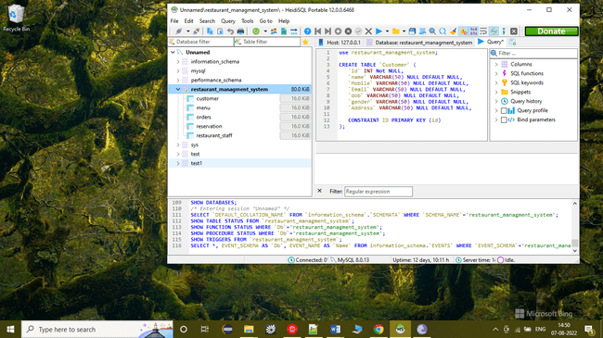

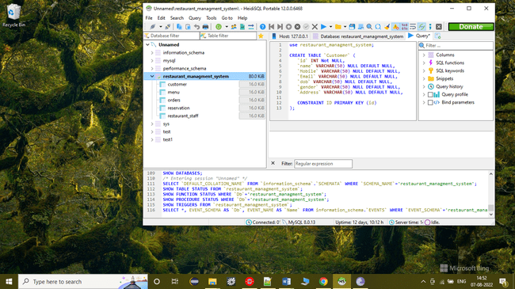

CREATE TABLE `Payment` (

`id` INT Not NULL,

`customer_id` INT Not NULL,

`datetime` VARCHAR(50) NULL DEFAULT NULL,

`type` VARCHAR(50) NULL DEFAULT NULL,

`total` float NULL DEFAULT NULL,

CONSTRAINT ID PRIMARY KEY (id)

);

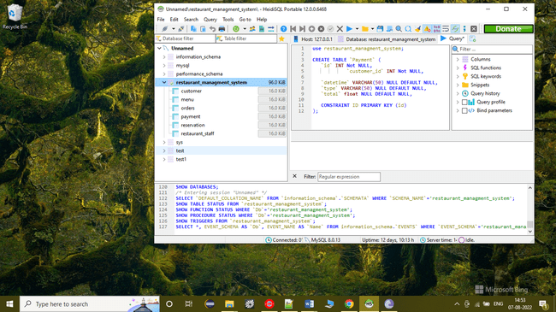

Loading data into tables

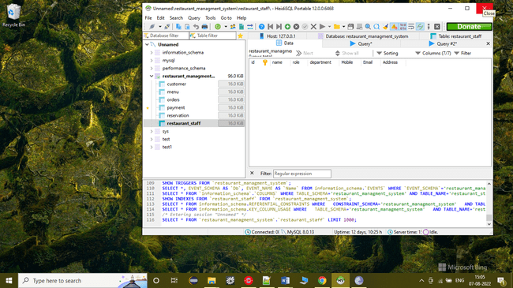

LOAD DATA LOW_PRIORITY LOCAL INFILE 'D:\\bin\\sql\\week2\\Restaurant_Staff.csv' REPLACE INTO TABLE

`Restaurant_Staff`

FIELDS TERMINATED BY ',' ENCLOSED BY '\'' ESCAPED BY '\'' LINES TERMINATED BY '\r\n' IGNORE 1 LINES;

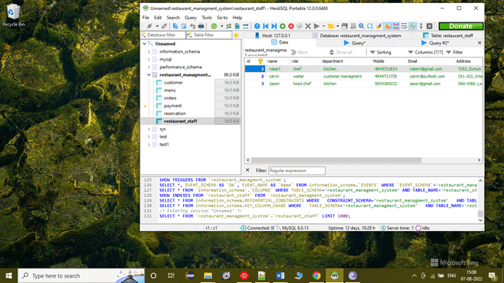

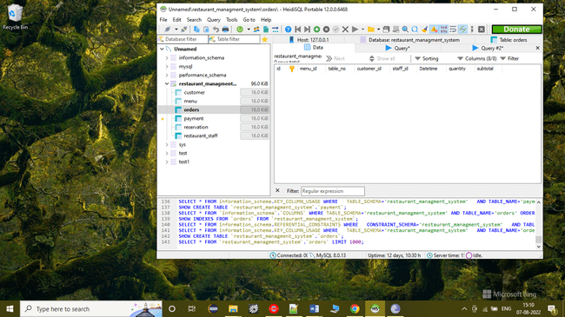

**LOAD** **DATA** **LOW_PRIORITY** **LOCAL** **INFILE** 'D:\\bin\\sql\\week2\\orders.csv' **REPLACE** **INTO** **TABLE**

`orders`

**FIELDS** **TERMINATED** **BY** ',' **ENCLOSED** **BY** '\'' **ESCAPED** **BY** '\'' **LINES** **TERMINATED** **BY** '\r\n' **IGNORE** 1 **LINES**;

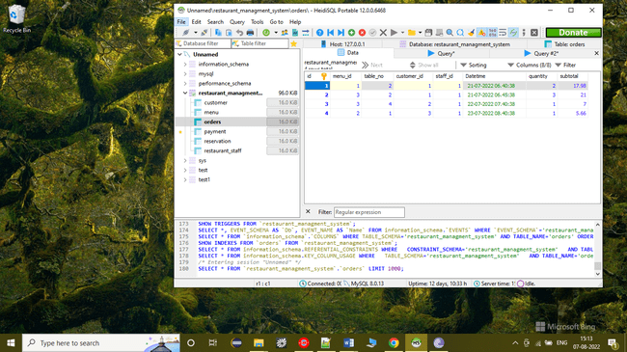

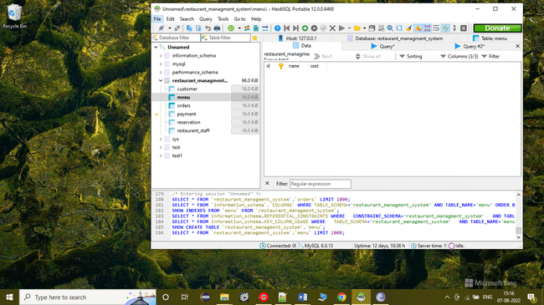

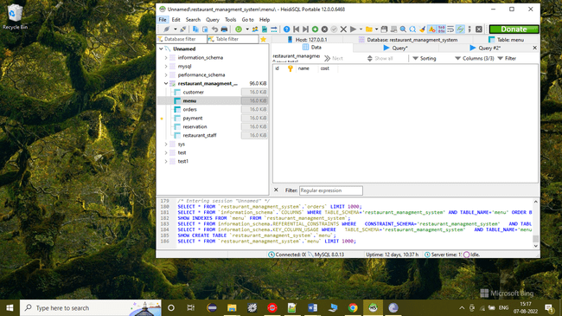

**LOAD** **DATA** **LOW_PRIORITY** **LOCAL** **INFILE** 'D:\\bin\\sql\\week2\\Menu.csv' **REPLACE** **INTO** **TABLE**

`menu`

**FIELDS** **TERMINATED** **BY** ',' **ENCLOSED** **BY** '\'' **ESCAPED** **BY** '\'' **LINES** **TERMINATED** **BY** '\r\n' **IGNORE** 1 **LINES**;

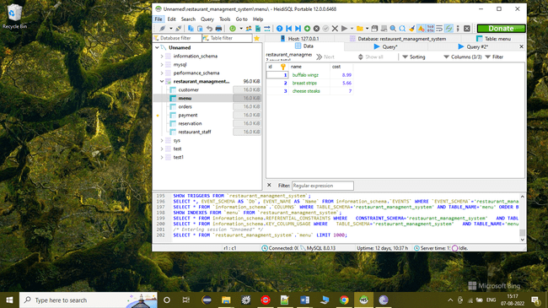

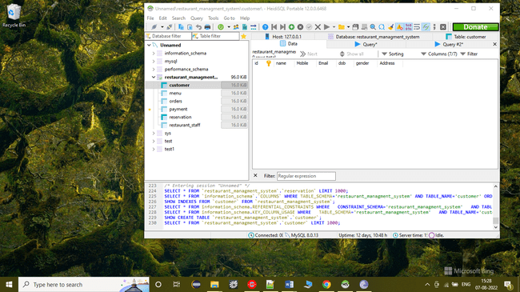

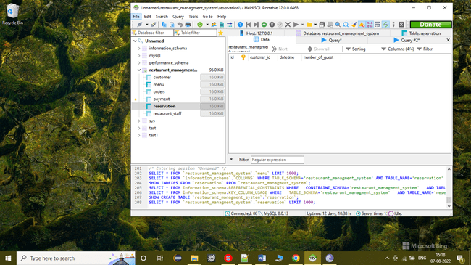

**LOAD** **DATA** **LOW_PRIORITY** **LOCAL** **INFILE** 'D:\\bin\\sql\\week2\\Reservation.csv' **REPLACE** **INTO** **TABLE**

`reservation`

**FIELDS** **TERMINATED** **BY** ',' **ENCLOSED** **BY** '\'' **ESCAPED** **BY** '\'' **LINES** **TERMINATED** **BY** '\r\n' **IGNORE** 1 **LINES**;

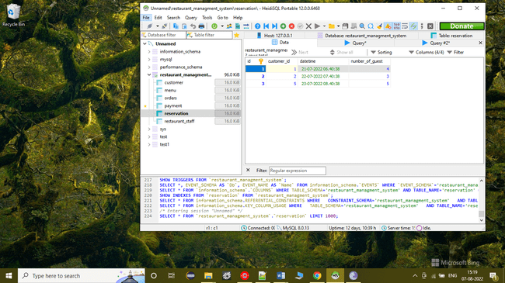

LOAD DATA LOW_PRIORITY LOCAL INFILE 'D:\\bin\\sql\\week2\\customer.csv' REPLACE INTO TABLE

`customer`

FIELDS TERMINATED BY ',' ENCLOSED BY '\'' ESCAPED BY '\'' LINES TERMINATED BY '\r\n' IGNORE 1 LINES;

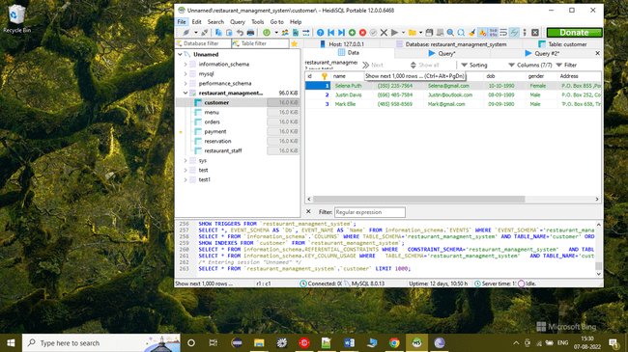

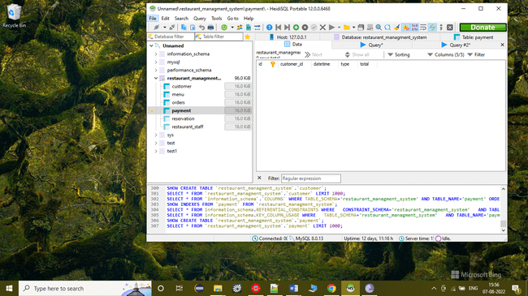

LOAD DATA LOW_PRIORITY LOCAL INFILE 'D:\\bin\\sql\\week2\\Payment.csv' REPLACE INTO TABLE

`payment`

FIELDS TERMINATED BY ',' ENCLOSED BY '\'' ESCAPED BY '\'' LINES TERMINATED BY '\r\n' IGNORE 1 LINES;

